NAME: G. Yashmita REG NO: 192511032
(JIRA)
EXPERIMENT 11:
Link Jira tasks with Confluence to streamline task tracking and
progress monitoring for the Library Management System
development.
• Create a new page in Confluence titled &quot;Library Management
System Project Overview.&quot;
• Embed at least 5 Jira issues related to the development of the
Library Management System (e.g., tasks from the sprint like
&quot;Develop book search functionality,&quot; &quot;Create user login page,&quot;
etc.).
• Use the Jira macro to display issues with status (e.g., &quot;To Do,&quot;
&quot;In Progress,&quot; &quot;Done&quot;).
• Add a progress bar in the Confluence page to visually track
the completion of each embedded Jira task (e.g., percentage of
tasks completed in the sprint).
• Submit a screenshot of the Confluence page showing the
embedded Jira tasks and the progress bar.

Aim

The objective of this experiment is to link Jira tasks with Confluence to streamline task tracking and monitor the development progress of a Library Management System using integrated Atlassian tools.

Software Requirements

Software: Jira Cloud, Confluence Cloud (Web Applications)
Web Browser: Google Chrome / Microsoft Edge
Internet Connection: Required

Theory

Jira and Confluence are widely used Atlassian tools for Agile software development and project documentation. Jira is used to create, assign, and track project tasks, while Confluence is used to create and manage project documents. By linking Jira issues with Confluence pages, teams can monitor task progress, improve collaboration, and maintain project documentation in one place. A progress tracker provides a visual representation of task completion, making project monitoring easier.

Procedure

Step 1:
Open a web browser and log in to your Atlassian account. Launch Confluence from the Atlassian workspace.
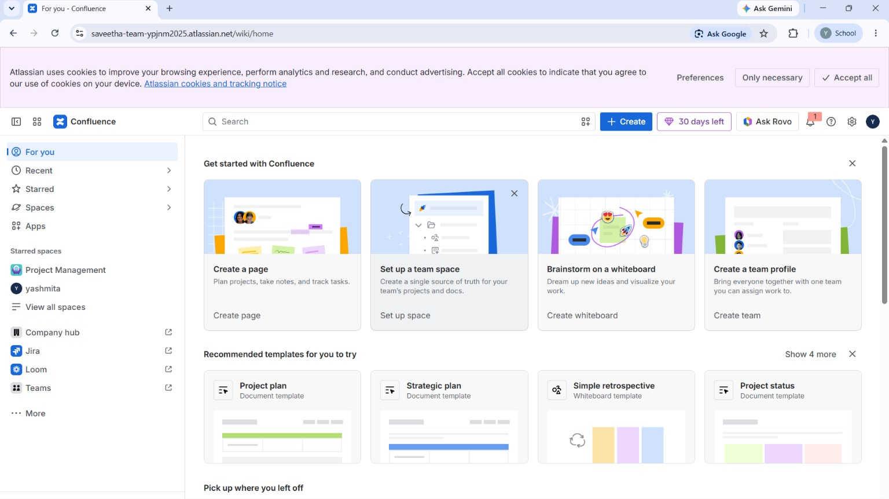
Figure 1. Opening Confluence.

Step 2:
Create a new Blank Page and enter the title "Library Management System Project Overview."
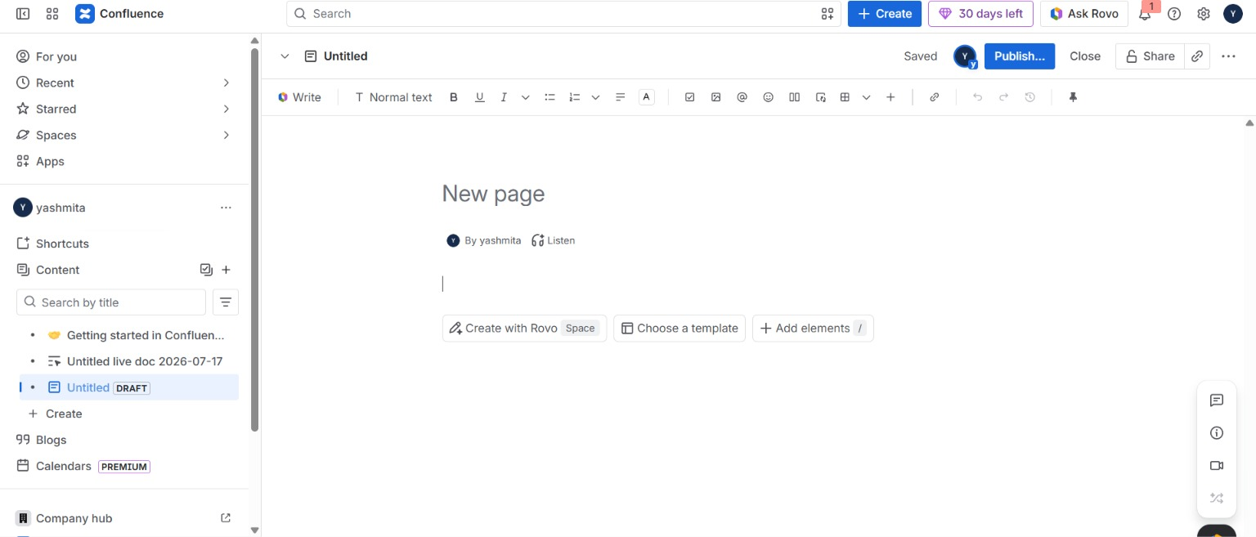
Figure 2. Creating a Confluence Page.

Step 3:
Open Jira Software and create at least five tasks related to the Library Management System. Assign appropriate workflow statuses such as To Do, In Progress, and Done.
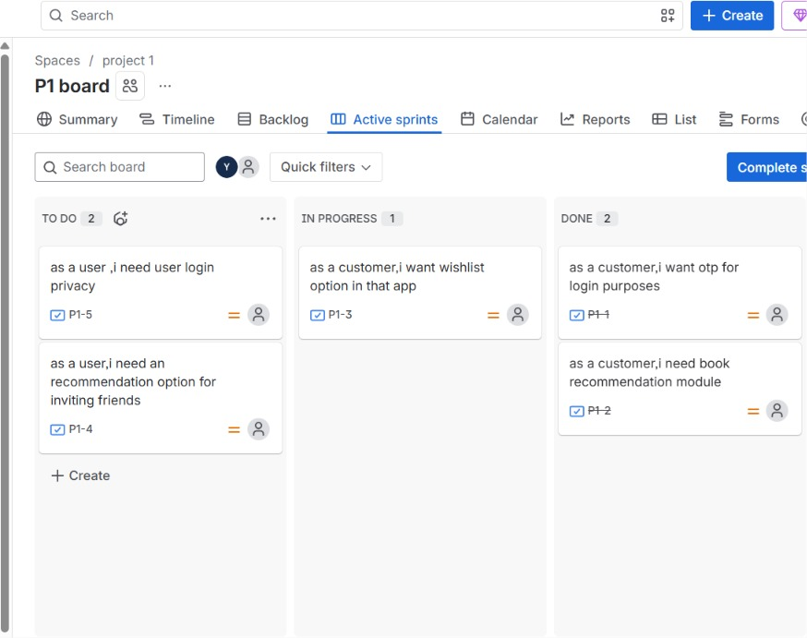
Figure 3. Creating Jira Tasks.

Step 4:
Return to the Confluence page and insert the Jira Macro using /Jira. Embed the created Jira issues into the page so that task details are displayed automatically.
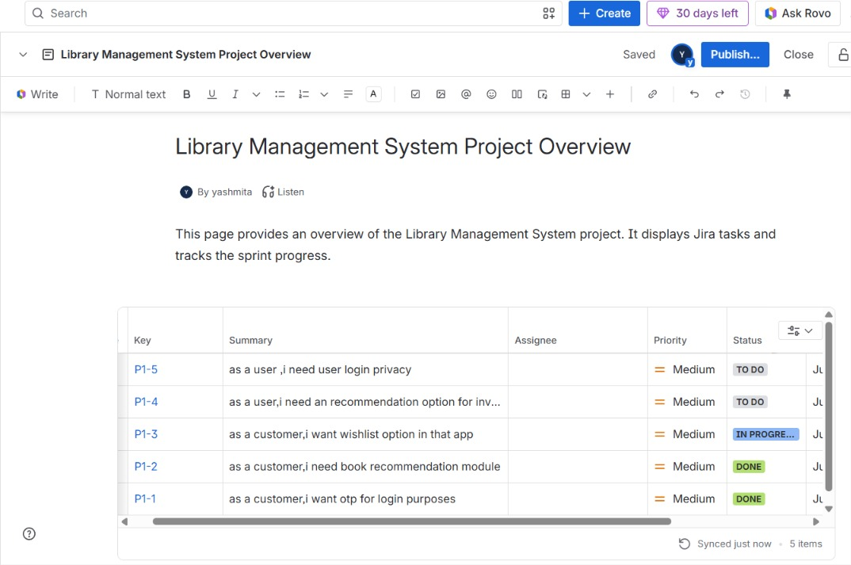
Figure 4. Embedding Jira Issues in Confluence.

Step 5:
Insert a Progress Bar (Progress Tracker) to display the overall completion percentage of the embedded Jira tasks.

Step 6:
Save and publish the Confluence page. Verify that all Jira tasks, their current statuses, and the progress tracker are displayed correctly.
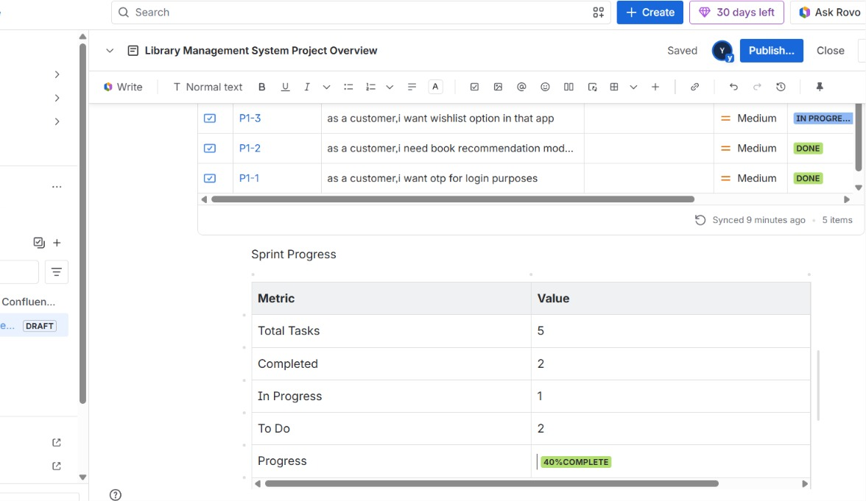
Figure 5. Published Confluence Page.

Result
The Jira tasks were successfully linked with Confluence using the Jira Macro. The embedded issues and progress tracker displayed the project status effectively, demonstrating how Jira and Confluence can be integrated to improve task management, documentation, collaboration, and progress monitoring during software development.

